Chad Magendanz & Peter Rimbos
chad@magendanz.com, primbos@comcast.net
Abstract
Draft proposal for Transportation Benefit District to improve access to I-90 from south of Issaquah, including areas of Mirrormont, May Valley, Hobart, Ravensdale, Maple Valley and Black Diamond.
Issaquah-Hobart Corridor
Congestion Relief Plan

Introduction
The Issaquah-Hobart corridor remains one of the most congested arterials in East King County, despite being the subject of a City of Issaquah Regional Transportation Summit in November of 2016 where it was cited as, “Issaquah’s most pressing regional transportation priority.” Congestion continues to increase along Front Street, Newport Way and through dense school zones along 2nd Ave. SE, driven mainly by pass-through traffic. In addition, new housing projects being constructed in Maple Valley (~2,500 units) and Black Diamond (~6,000 units) are expected to greatly exacerbate the congestion along this corridor in upcoming years.
While the Regional Transportation Summit did generate an Issaquah-Hobart Corridor Traffic Study funded by the City of Issaquah and King County, the recommended project list from this study failed to address the major congestion chokepoints within the Issaquah city limits that were originally addressed by the SE Issaquah Bypass project included as part of the Master Transportation Financing Agreement in 1996. The consensus of stakeholders was that an Issaquah-Hobart corridor project list that simply shifts congestion into the Issaquah city limits is no solution at all, and so we’ve expanded our draft plan to include a scaled-back version of the SE Bypass.
Finally, current rules and regulations governing city government and government agencies are impeding, restricting, or prohibiting meaningful change in our transportation system. No relevant and timely change can occur until these barriers are removed.

Funding Strategy
Since those who benefit from Issaquah-Hobart congestion relief are primarily residential areas south of the Issaquah city limits, it seems inappropriate that only one municipality should bear the cost. The proposed remedy is formation of a new Transportation Benefit District funded by a Local Improvement District bond (RCW 36.73.080) by King County. The TBD will need to specifically pursue grants for many of the recommended projects. These have been called out in the corridor study.

Proposed Project List
The recommended projects either scored highest in the project prioritization process or were highlighted as important by stakeholders. They are considered most important for near to mid-term implementation. These projects address the intersections and corridor segments that are critical to the movement of both vehicles and people. They comprise a combination of new and previously-identified improvements. The recommended projects, along with their evaluation criteria scores, are shown in the following table:
No. | Project Description | Score | Estimate
W-1 | Issaquah-Hobart Rd & Cedar Grove Rd. Intersection Improvement. Construction of a roundabout or additional through lanes. |  | $3,303,000
W-2 | Issaquah-Hobart Rd & May Valley Rd. Intersection Improvement. Construction of a roundabout or additional through lanes. |  | $2,252,000
W-3 | Issaquah-Hobart Rd & May Valley Rd. Interim. Extend northbound and eastbound left turn lanes. |  | $1,267,000
W-4 | SE Issaquah Bypass. Principal arterial extending south from Sunset Interchange through 6th Ave. SE to intersection with Front St. |  | TBD

Notes:
- Cost estimates are in 2018 dollars, based on March 2018 corridor study

Related Projects
There are two related projects in the pipeline for SR-18 that will should eventually improve traffic flow along those highways, reducing the need for diversion along the Issaquah-Hobart corridor. The I-90/SR-18 Interchange Improvements are tentatively scheduled to break ground in 2020 and complete in 2023. Additionally, completion of the SR-18 widening project from Auburn to I-90 has design phase funding for the 2017-19 biennium to complete the section from Issaquah-Hobart Rd. exit to the I-90 intersection. However, additional funding for completion of this work will be required in the next transportation package, setting the timeline out many years.
Although efforts have been made to make SR-169 a Highway of Statewide Significance (HSS), this has not resulted in prioritization of state funding to continue widening the arterial from Jones Rd. to the Maple Valley or Black Diamond communities. Until this project is in the funding pipeline and completed, significant diversionary traffic to the Issaquah Hobart corridor will continue.

Intersection Improvements
Improvements to intersections typically enhance the safety and mobility of vehicles and nonmotorized users. Potential improvements could include intersection realignments, changes in intersection traffic control, restrict left turns at intersection during peak hours, constructing a roundabout, seagull intersection, or adding turn lanes or turn pockets.
Typically, these improvements can be completed in a short time frame (5 years or less) and cost roughly between $1 million and $5 million dollars.

SE Bypass History
While the City of Issaquah was contractually obligated to construct the SE Bypass as part of the 1996 Master Transportation Financing Agreement (MTFA) with King County and the developers of the Issaquah Highlands, the City Council voted 5 to 2 to select the “No Build” alternative and project work was terminated in March 2008. This was driven not only by the high project cost, but also by members of the Issaquah Environmental Council who wished to stop development of the Park Pointe housing project on Tiger Mountain.
Thanks to a Transfer of Development Rights (TDR) in March 2011, the entire Park Pointe area on Tiger Mountain was preserved and protected from development. In addition, during the subsequent years the influence of the IEC on the City Council has waned, enabling the promised retail build-out of the Issaquah Highlands and other postponed development projects in the Central Corridor. With the cost of the SE Bypass project possibly funded through a LID and increasing congestion from pass-through traffic being Issaquah’s most pressing priority, it seems that reconsideration of the SE Bypass is due.

Cost Estimates
The MFTA estimated the cost for the SE Bypass at $16.7M, which corrected for inflation at 3% annual rate is $32M. However, the estimate for the “Preferred Alternative” (Modified Alternative 5) in the Environmental Impact Study was $43.5M in 2009, or about $56.8M in 2018 dollars.
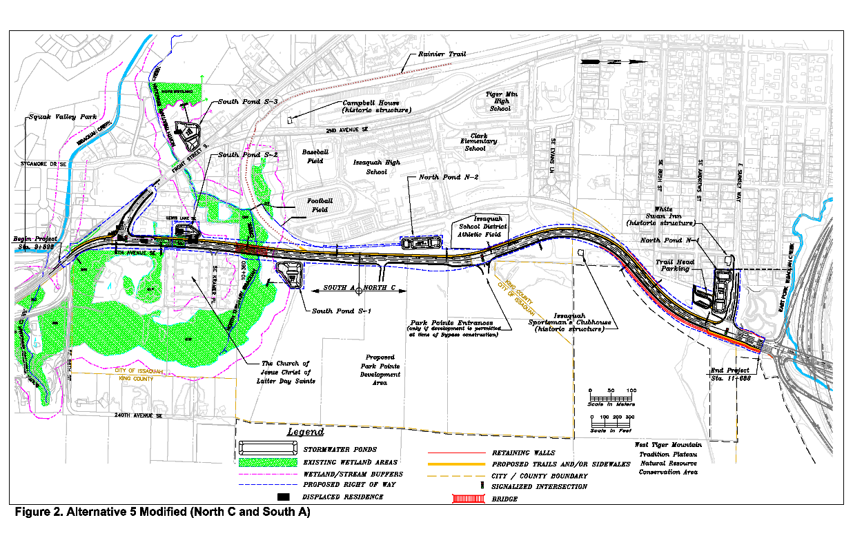
However, many elements of the preferred design may no longer be needed. Specifically,
- Two entrances to the cancelled Park Pointe development, one with a traffic light
- Four lanes wide, increasing to 5 lanes with 3 right-hand turn pockets
- Sidewalk along the full length
Our draft proposal removes both Park Pointe entrances, the sidewalk, and scales back to 2 lanes and only 1 turn pocket southbound at 6th Ave. and Front Street. It’s also unclear whether we would need all 4 retention ponds with the scaled back project.

Formation of Transportation Benefit District
According to RCW 36.73.020, a Transportation Benefit District “may include area within more than one county, city, port district, county transportation authority, or public transportation benefit area, if the legislative authority of each participating jurisdiction has agreed to the inclusion as provided in an interlocal agreement adopted pursuant to chapter 39.34 RCW.” The plan is for King County staff to draft this interlocal agreement and then our stakeholder groups will work to advocate for its passage in the following councils:
- City of Issaquah
- City of Maple Valley
- City of Black Diamond
- King County
Once the Transportation Benefit District is formed, its board can form a multi-jurisdiction Local Improvement District (LID) for transportation improvements in accordance with RCW 36.73.080 either by resolution or petition methods. There are many financing tools available to a LID to fund these road improvements, but the assumption here is that we would require passage of a bond measure with at least 60% voter support.

Scope of Local Improvement District
While the Regional Transportation Summit included a large set of Eastside municipalities, the Issaquah-Hobart corridor is much more limited and therefore better suited for funding through a LID. Final boundaries will be determined through analysis of a detailed origin-destination study, but the draft proposal is to include the following 80 precincts:

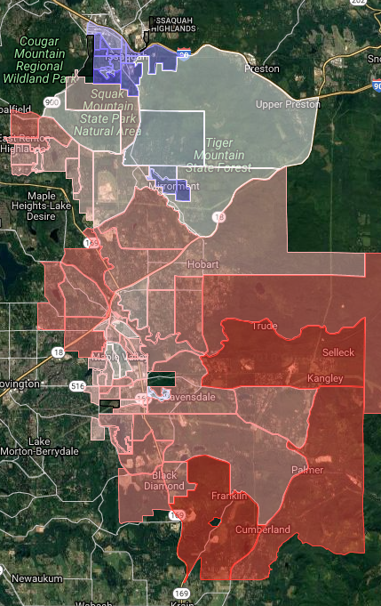
Name | ID | Voters
ARTHUR | 0037 | 895
B-D 05-0239 | 0239 | 586
B-D 05-0240 | 0240 | 436
B-D 05-2407 | 2407 | 866
B-D 05-2413 | 2413 | 471
B-D 05-3310 | 3310 | 507
BITTERROOT | 3294 | 519
BRIARWOOD | 3525 | 567
CEDAR RIVER | 0301 | 482
COLLEEN | 2803 | 492
CROW | 3468 | 389
CUMBERLAND | 0348 | 353
DORRE DON | 0379 | 814
FOUR LAKES | 2460 | 751
GREEN RIVER | 0487 | 478
HAAS | 2566 | 320
HI-VALLEY | 0520 | 860
HOBART | 0522 | 659
HUSKY | 2606 | 785
HUTCHINSON | 0534 | 671
IDA | 3437 | 267
ISS 05-0543 | 0543 | 614
ISS 05-0544 | 0544 | 670
ISS 05-0545 | 0545 | 313
ISS 05-0546 | 0546 | 221
ISS 05-0547 | 0547 | 341
ISS 05-0548 | 0548 | 744
ISS 05-0550 | 0550 | 300
ISS 05-2461 | 2461 | 571
ISS 05-2806 | 2806 | 400
ISS 05-2929 | 2929 | 596
ISS 05-3138 | 3138 | 434
ISS 05-3206 | 3206 | 830
ISS 05-3711 | 3711 | 470
ISS 05-3712 | 3712 | 43
ISS 05-3714 | 3714 | 332
KENTLAKE | 3523 | 693
LAKE RETREAT | 3474 | 666
LUND | 3295 | 755
M-V 05-0528 | 0528 | 341
M-V 05-0697 | 0697 | 696
M-V 05-1218 | 1218 | 713
M-V 05-2614 | 2614 | 860
M-V 05-2748 | 2748 | 834
M-V 05-2841 | 2841 | 383
M-V 05-2857 | 2857 | 706
M-V 05-3242 | 3242 | 575
M-V 05-3245 | 3245 | 665
M-V 05-3272 | 3272 | 567
M-V 05-3322 | 3322 | 390
M-V 05-3366 | 3366 | 447
M-V 05-3367 | 3367 | 789
M-V 05-3368 | 3368 | 835
M-V 05-3369 | 3369 | 722
M-V 05-3373 | 3373 | 683
M-V 05-3461 | 3461 | 899
M-V 05-3482 | 3482 | 914
M-V 05-3510 | 3510 | 386
M-V 05-3536 | 3536 | 634
M-V 05-3589 | 3589 | 818
M-V 05-3600 | 3600 | 641
M-V 05-3601 | 3601 | 522
M-V 05-3717 | 3717 | 364
MAPLE HILLS | 0717 | 728
MATTHEW | 2810 | 491
MAY VALLEY | 0741 | 497
MCCOY | 2405 | 673
MCDONALD | 0703 | 531
MIRRORMONT | 0812 | 442
NAILA | 2603 | 767
PRESTON | 0919 | 681
RAVENSDALE | 0932 | 501
RIVERSIDE | 1024 | 395
SELLECK | 1062 | 794
SHADOW LAKE | 1068 | 628
SQUAK MOUNTAIN | 1113 | 188
SWEENEY | 2859 | 577
TAHOMA | 1139 | 600
TANNER | 1141 | 704
TIGER MTN | 1152 | 731
Total |  | 46,473

Action Items
- Draft interlocal agreement to form Transportation Benefit District (King County)
- Origin-Destination Study to support LID boundaries (TBD board)
- Revised estimate for scaled-back SE Bypass project (City of Issaquah)
- Ordinance to create Local Improvement District (TBD board)
- Ballot measure for LID financing (TBD board & stakeholder groups)

Contacts for Stakeholder Groups
- Chad Magendanz – Mirrormont, Safe Roads for Issaquah
- Peter Rimbos – Greater Maple Valley Unincorporated Area Council
- Susan Harvey – Greater Maple Valley Unincorporated Area Council
- Stephen Deutschman – Greater Maple Valley Unincorporated Area Council
- Lorraine Blacklock – Greater Maple Valley Unincorporated Area Council
- Tom Goff – King County Council Staff
- Bryn Vander Stoep – King County Council Staff
- Les Burberry – Maple Valley City Council

References
- Issaquah-Hobart Road / Front Street Corridor Study (Feb. 2017)
- City of Issaquah Regional Transportation Summit Agenda (Nov. 2016)
- Regional Transportation Summit Map, built using each city’s worksheet.
- SE Issaquah Bypass Environmental Impact Statement – Vol 1, Vol 2 (Dec. 2007)
- Master Transportation Financing Agreement (June 1996)

Revision History
Version | Date | Description | Reviewer or Author
1.0 | 6/26/2018 | Initial Draft | Chad Magendanz
1.1 | 6/28/2018 | Incorporated feedback from Peter Rimbos | Chad Magendanz
1.2 | 10/30/2018 | Minor edits based on feedback from 10/29 GMVUAC JTI Meeting | Chad Magendanz
1.2.1 | 11/19/2018 | Added revision history and footers | Chad Magendanz

